Website Planning Document

**Weather Project**

Author: Brennan Neilson

Site Purpose

To inform users in the designated regions of upcoming weather forecasts.

Target Audience

Residents and visitors within the three designated cities – Franklin, Greenville, and Springfield.

Site Map

<https://atlas.mindmup.com/2017/08/92399660795811e7be6cf7b165db6f4d/weather/index.html>

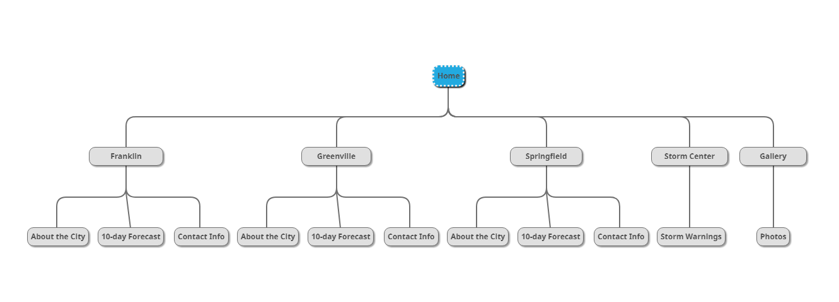

Color Scheme



[#636154](http://www.color-hex.com/color/636154) - Gray

[#6ac6f9](http://www.color-hex.com/color/6ac6f9) - Blue

[#fbed63](http://www.color-hex.com/color/fbed63) - Yellow

[#ffb748](http://www.color-hex.com/color/ffb748) - Orange

[#f0341f](http://www.color-hex.com/color/f0341f) - Red

Typography

Primary text fonts: Open Sans and Open Sans Condensed

Open Sans will be used everywhere except <p> text.

Open Sans Condensed will be used in <p> text.

Wire-Frame Sketches